**Traffic Flow optimization and Congestion Management**

**Problem statement 2 -** Mechanism to measure the traffic flow optimization at each junction once signal time optimization is achieved.

**INDIRANAGAR KFC JUNCTION SIGNAL**: 4 arms Junction.

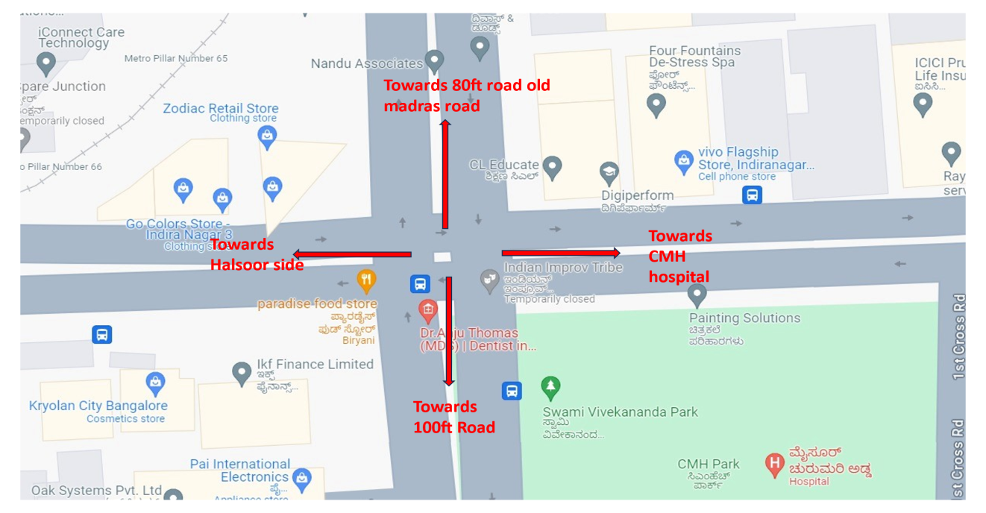

**1st CYCLE:** -

10:00:15 to 10:00:50 (35 sec) open from CMH Road towards Halsoor.

10:00:50 to 10:01:00 (10 sec) pedestrian crossing.

10:01:00 to 10:01:50 (50 sec) open from 100ft Road towards 80ft Road Old Madras Road.

10:01:50 to 10:02:20(30 sec) open towards 100ft Road from 80ft road Old Madras Road.

10:02:20 to 10:03:00(40sec) open from Halsoor towards CMH Hospital Road.

**2nd CYCLE: -**

10:03:00 to 10:03:35(35 sec) open from CMH Road towards Halsoor.

10:03:35 to 10:03:45 (10 sec) for pedestrian crossing.

10:03:45 to 10:04:30 (45 sec) open from 100ft Road towards 80ft Road Old Madras Road.

10:04:30 to 10:05:00(30 sec) open towards 100ft Road from 80ft Road Old Madras Road.

10:05:05 to 10:05:45(40sec) open from Halsoor towards CMH Hospital Road.

**3rd Cycle: -** This cycle Continues as above

Note: Based on Vehicle actuated signals / Queue length using camera or radars, the signal optimal time is calculated. The generated Green time (optimal signal time) for the Indiranagar KFC junction handles how many vehicles during the current cycle time for different arms? How many vehicles it could have handled in an ideal situation when better traffic disciplines along with signage are in place for different arms? Comparison and analysis of both the outcomes to provide actionable inputs on achieving the traffic flow optimization vis-a-vis signal optimal time.

**CHICKPET TPS JUNCTION SIGNAL:** 3 arms junction with one way restrictions towards 5th Main Road

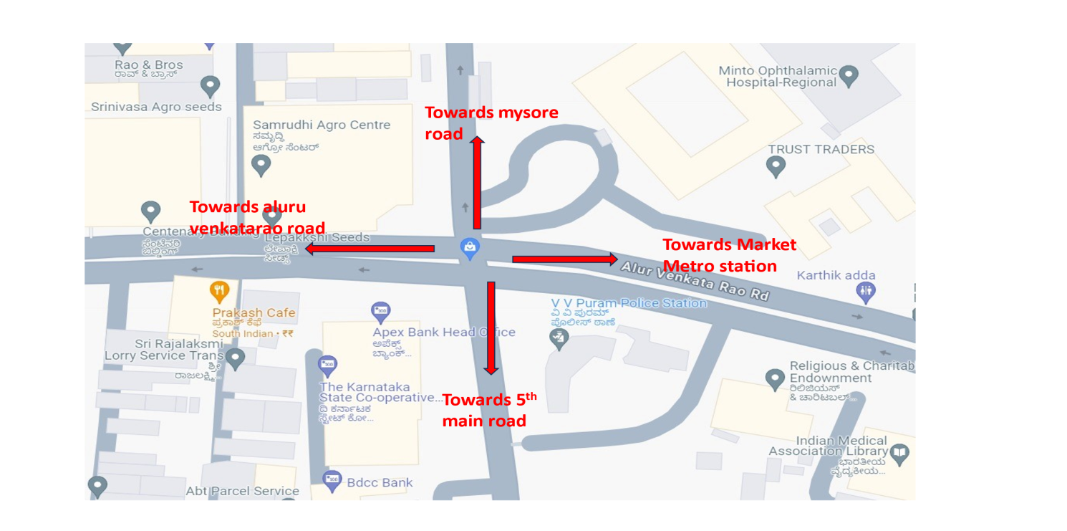

**1st CYCLE: -**

10:00:14 to 10:01:10 (50 sec) open signal towards Mysore Road from 5th Main Road.

10:01:15 to 10:01:50 (35 sec) signal is open from Market Metro Station to Alur Venkata Rao Road.

10:01:50 to 10:02:30 (40 sec) open from Alur Venkat Rao Road towards Market Metro station.

10:02:30 open signal towards Mysore Road.

**2nd CYCLE: -**

10:02:30 to 10:03:20(50 sec) open signal towards Mysore Road from 5th Main Road.

10:03:20 to 10:03:55 (35 sec) signal is open from Market Metro Station to Alur Venkata Rao Road.

10:03:55 to 10:04:35 (40 sec) open from Alur Venkat Rao Road towards Market Metro station.

10:04:35 open signal towards Mysore Road.

**3rd Cycle: -** This cycle Continues as above cycle.

Note: Based on Vehicle actuated signals / Queue length using camera or radars, the signal optimal time is calculated. The generated Green time (optimal signal time) for the Chikpet Traffic PS junction handles how many vehicles during the current cycle time for different arms? How many vehicles it could have handled in an ideal situation when better traffic disciplines along with signage are in place for different arms? Comparison and analysis of both the outcomes to provide actionable inputs on achieving the traffic flow optimization vis-a-vis signal optimal time.